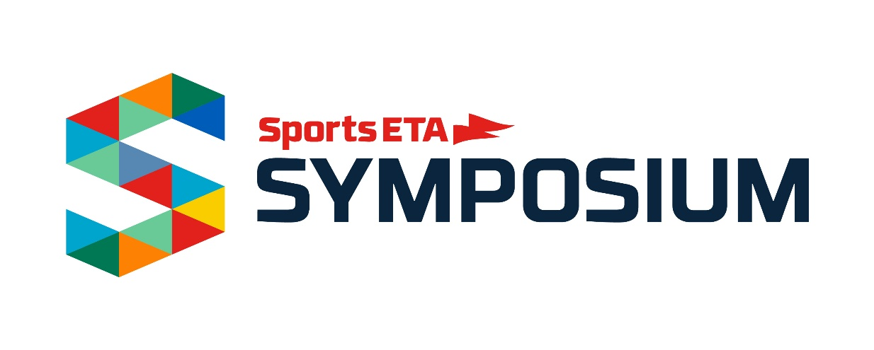

Letter to Boss
On the next page, you'll find a "justification letter" template — a letter to your boss explaining all the benefits you'll get from attending the Sports ETA Symposium, how it will make you a better employee, and help advance your organization.
This general template will get you started while allowing you to customize it to you and your organization's particular needs.

<Date>
Dear <boss>,
I received an invitation to attend the upcoming Sports ETA Symposium, the annual meeting of the Sports Events & Tourism Association (Sports ETA) in Tulsa, Oklahoma, April 14-17, 2025. Sports ETA is the most essential resource for sports event owners. The conference has over 1,000 attendees will allow me to meet face-to-face with sports destinations and industry partners (vendors) during pre-scheduled one-on-one appointments in the Sports Marketplace. These appointments will save me time and money, but it will also allow me to be more efficient at my job.
Additionally, by attending the Sports ETA Symposium I will have access to number of educational opportunities that are specific to event owners like our organization. These sessions are directly applicable to my work and will allow me to network with a variety of industry experts and colleagues from around the country.
Since our organization is a member of Sports ETA, there are no registration costs to attend the Symposium. I am responsible for booking my airfare but will be reimbursed up to $500 via check after completing all scheduled appointments. Additionally, Sports ETA will provide me a secure link to book my own hotel room in their group block, and Sports ETA will cover up my hotel room for up to 4-nights.
The opportunity for me to develop better contacts and gain knowledge in specific areas of <your area of expertise> makes my attendance at the Sports ETA Symposium a wise investment, which will yield rich dividends for <name of your organization>. Upon my return from the conference, I will share the information I gather with you and the rest of the team.
Thank you in advance for your consideration,
<your name here>

